Self help resources:
On the current mock up of the website under resources there is HHSCF Positive pathways…Keep this here and have it as a flip book
Remove these:
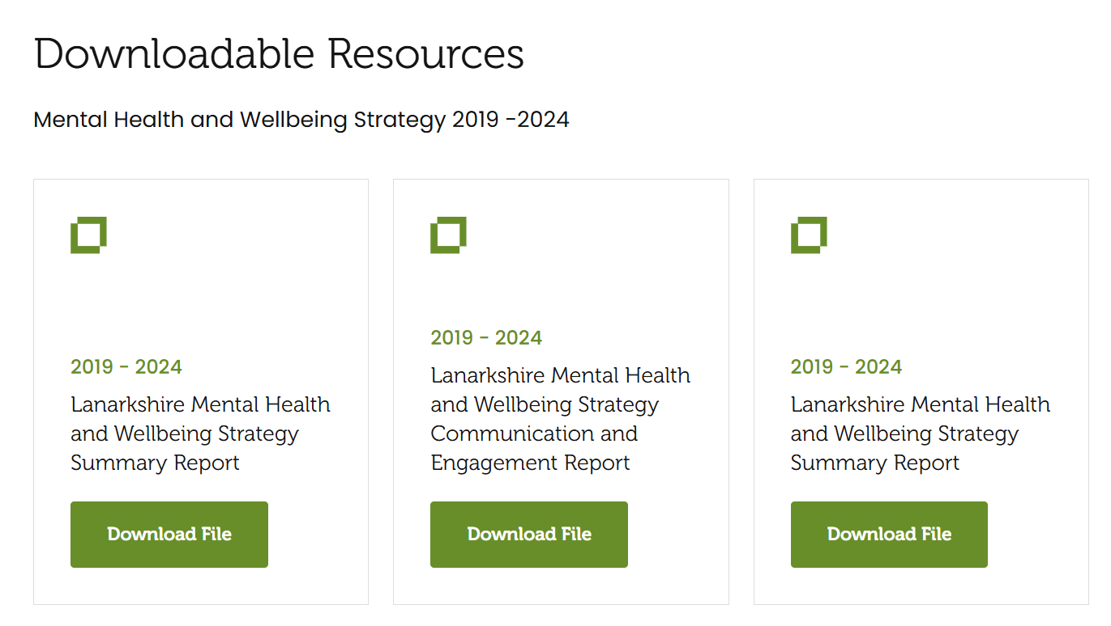
Keep the video resources
In the section below the wellbeing matters bit is fine, the middle one can you make it NHS Inform with the following link please: https://www.nhsinform.scot/healthy-living/mental-wellbeing/get-help-with-your-mental-health
Then the third one NHS Lanarkshire Logo and when you click on it, it takes you here: https://www.nhslanarkshire.scot.nhs.uk/patient-information-leaflets/mental-health/
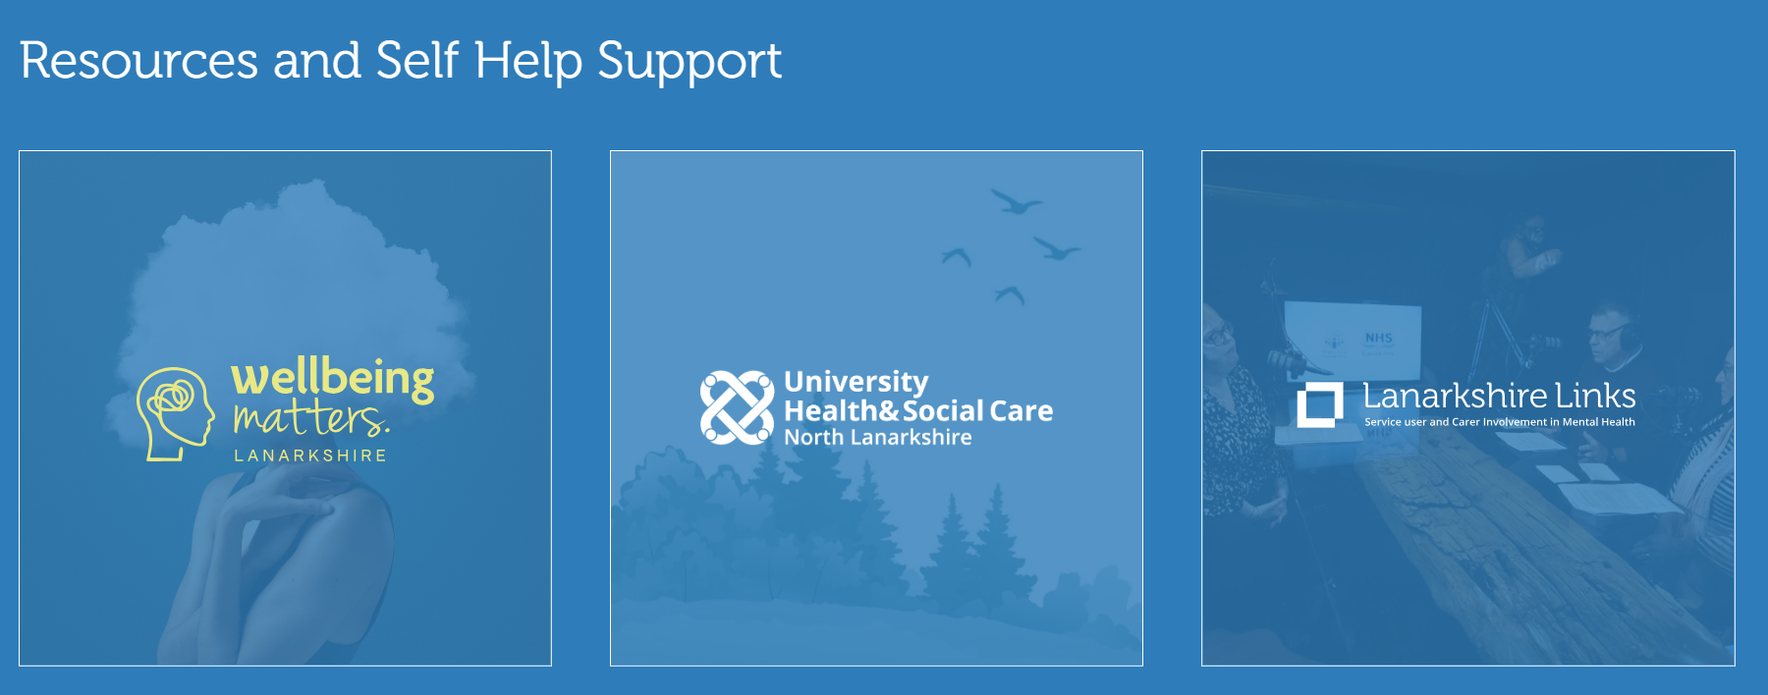
5 ways to wellbeing (have the poster) then underneath the poster the following links:
https://health-in-mind.org.uk/resources/beating-the-winter-blues/5-ways-to-wellbeing/
https://www.mind.org.uk/workplace/my-mental-health-at-work/five-ways-to-wellbeing/
Lanarkshire Keep safe resource (have the poster)
Well connected brochure (have booklet as a flip book)
Lanarkshire Mind Matters (have video – A Moment For Your Mind) then underneath the poster the following link:
https://www.lanarkshiremindmatters.scot.nhs.uk/

Self help resources for young people
Kooth (have their logo) followed by a link:
https://www.kooth.com/
Wellbeing South Lan (logo) and when you click on it, it takes you here:
https://www.wellbeingsouthlan.co.uk/
In Crisis
In the section below…can you put this at the bottom or in the In Crisis section and can you put NHS 24 first then breathing space and then Samaritan
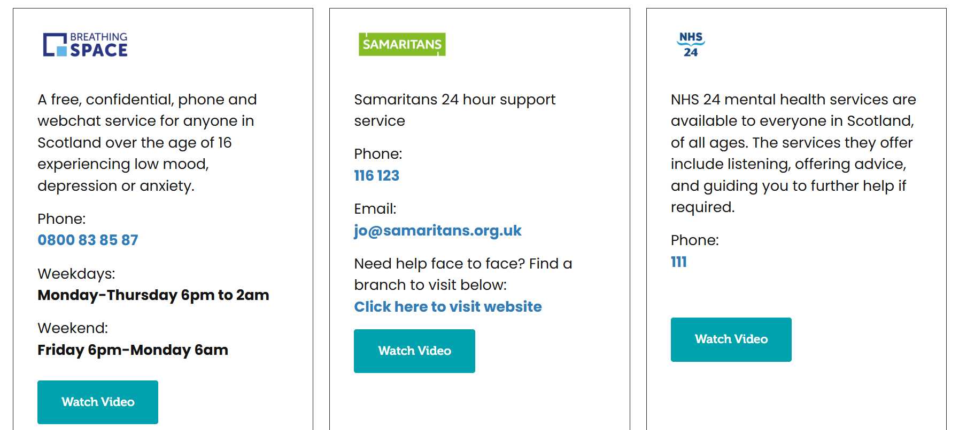
Then after this have
Self Harm (have NHS Self harm booklet as a flip book)
Suicidal Thoughts
https://wellbeingmatterslanarkshire.co.uk/get-help-now/

